Cameron Tranthim-Fryer 10395364

CSTRANTH@OUR.ECU.EDU.AU

CSG6224 Special Topic 1  
Semester 1 2016

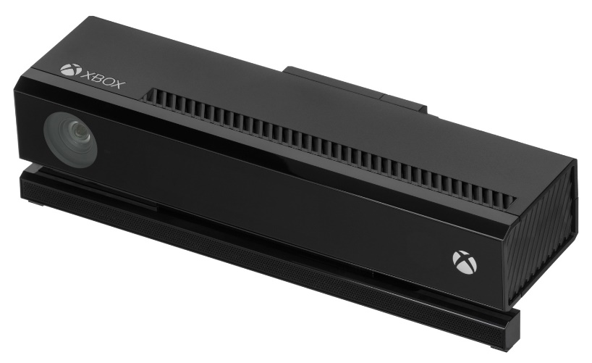

Sleep Monitor Project

Technical Documentation

Table of Contents

1.0 Project Methodology 3

2.0 Development Tools 3

3.0 Libraries 3

3.1 OpenCV 3.10 3

3.2 EmguCV 3.10 4

4.0 Configuring the Development Environment 4

4.1 Development Platform 4

4.2 Compiling OpenCV 4

4.3 Integrating OpenCV and EmguCV with Visual Studio 6

5.0 Program Structure 7

5.1 Sleep Monitor Main Window (Form1.cs, Form3.cs, and Form4.cs) 7

5.2 Management Class (Management.cs) 9

5.3 Preferences (Form6.cs and Form2.cs) 9

5.4 About This Software (Form5.cs) 11

5.5 Help 11

References 12

Appendix 1 – OpenCV Licence 13

Appendix 2 – EmguCV Licence 14

Appendix 3 – Sleep Monitor Main Window 17

Appendix 4 – Output.csv 18

# 1.0 Project Methodology

The software is designed to semi automate the analysis of sleep images by detecting points where the sleep position has changed and allowing the user to classify each sleep position and add comments to any frame in the image series.

The method used to determine sleep position changes is called “frame difference” and works by summing the values of the pixels in two consecutive images and calculating the difference between these two values. If the value is greater than the threshold value set by the user, the software marks this position as a sleep position change. The chart including frame difference (blue line), threshold (red line), sleep segment markers (orange lines), and playback position (green line) is shown in Appendix 3 – Sleep Monitor Main Window.

Best results are obtained when using depth images for frame differencing. Infrared images provide a clearer image to allow the sleep researcher to gather information about the sleep position, and for this reason the software loads two series of images and enables the sleep researcher to toggle the display between the two.

Once the analysis is complete, the software exports the analysis to a CSV file. A sample is included in Appendix 4 – Output.csv.

# 2.0 Development Tools

The application is built on the Microsoft .NET Framework 4.5.2 using the C# language and is a 64 bit application. C# is a popular development language because it inherits many of the best features of C++ and Microsoft Visual Basic, but has cleaner syntax and is easier to use (Sharp, 2007). The GUI is developed using WinForms as this platform was the most efficient option for building a desktop application. The IDE used was Visual Studio Enterprise, however none of the features exclusive to this version were used and the project is also compatible with Visual Studio Community and Visual Studio Professional.

# 3.0 Libraries

## 3.1 OpenCV 3.10

OpenCV is an open source computer vision and machine learning software library written in C++ and originally developed by Intel (“OpenCV About,” 2016). OpenCV has bindings for C++, Java, Python and Matlab. OpenCV is used by the Sleep Monitor Project to calculate the sum of the pixel values for each image, and for simple image processing such as x axis flipping of the image before it is displayed in the picture box.

OpenCV is licenced under the 3 clause BSD licence (see Appendix 1 – OpenCV Licence) which exempts the copyright owners from any liability arising from use of the software and allows it to be used by the Sleep Monitor Project without any conditions other than the requirement for distributions of the project in either source code or binary form to be accompanied by this licence.

## 3.2 EmguCV 3.10

EmguCV is a .NET wrapper for OpenCV which allows its functions to be accessed using .NET compatible languages such as C#, VB, VC++, and IronPython (“EmguCV Wiki,” 2016).

EmguCV is licenced under a dual licence system (see Appendix 1 – EmguCV Licence). If an open source licence is used then the project must also be licenced as open source and shared with the open source community. If EmguCV is to be used to derive commercial advantage then a commercial licence must be used and the code does not need to be shared with the open source community (“EmguCV Licencing”, 2016). A commercial licence for EmguCV costs US$199 for a single developer (“EmguCV Commercial Licence Purchase”, 2016).

# 4.0 Configuring the Development Environment

## 4.1 Development Platform

The steps below are from the EmguCV download and installation instructions (“EmguCV Download and Installation,” 2016) and are to be performed on an x64 compatible PC running Windows 7 or later with the following software installed:

|  |  |
| --- | --- |
| Name | Source |
| Visual Studio 2015 (Community, Professional, or Enterprise) | <https://www.visualstudio.com/en-us/downloads/download-visual-studio-vs.aspx> |
| EmguCV Version 3.1 For Windows | [https://sourceforge.net/projects/emgucv/files/emgucv /3.1.0/libemgucv-windesktop-3.1.0.2282.exe/download](https://sourceforge.net/projects/emgucv/files/emgucv/3.1.0/libemgucv-windesktop-3.1.0.2282.exe/download) |
| CMake | <https://cmake.org/download/> |

## 4.2 Compiling OpenCV

Download and extract the OpenCV source code from:

<http://sourceforge.net/projects/opencvlibrary/files/opencv-win/3.1.0/opencv-3.1.0.exe/download>

The steps below assume that the OpenCV source files are extracted to the folder C:/Users/Cameron/Downloads/opencv

Open CMake and configure as per the screenshot below, then click the “Configure” button at the bottom of the screen.



As per the screenshow below, expand the “Build” node and ensure that the only lines containing “opencv” that are ticked are “opencv_core” and “opencv_imgproc”. Then click the “Generate” button at the bottom of the screen.



Next, open the file C:/Users/Cameron/Downloads/opencv/build/OpenCV.sln with Visual Studio and build the project.

Once the project has finished compiling, the files opencv_core310d.dll and opencv_imgproc310d.dll will be in the folder C:\Users\Cameron\Downloads\opencv\build\bin\Debug. Copy these files to a safe location and the folder C:\Users\Cameron\Downloads\opencv can now be deleted.

## 4.3 Integrating OpenCV and EmguCV with Visual Studio

Create a new project in Visual Studio.

In the solution explorer section, right click on the References section, select Add Reference and add the reference: C:\Emgu\emgucv-windesktop 3.1.0.2282-2\bin\Emgu.CV.World.dll

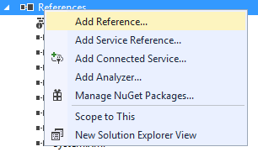

Right click on the project and select “Add”, then “Existing item



Add the DLL file C:\Emgu\emgucv-windesktop 3.1.0.2282-2\bin\x64\cvextern.dll, and then complete this step again to add the two DLL files created in part 3.2 above.

Finally, add the following two lines to any files that will be using OpenCV and those files will be able to access the OpenCV functions:

using Emgu.CV;

using Emgu.CV.Structure;

# 5.0 Program Structure

## 5.1 Sleep Monitor Main Window (Form1.cs, Form3.cs, and Form4.cs)

The Sleep Monitor main windows is initiated by launching Form1.cs when the program starts. A screenshot of the main window is shown in Appendix 3 – Sleep Monitor Main Window. An explanation of each section of the code and its purpose is outlined in the table below:

|  |  |
| --- | --- |
| Section | Purpose |
| Constructor | Initiates the form when it is first loaded. Clears the GUI, and chart and sets the waitTime variable which determines the playback speed to the value in App.config. |
| Timer | The timer is used to update the image displayed to provide playback of the image series. When a region on the chart is clicked, the behaviour of the timer is modified so that either the threshold line, or playback position is modified depending on the region clicked. |
| GUI | Updates the the regions of the form below when a new image is loaded, when the chart is modified, and when the form is reset to its initial state:   * 2. Picture box * 5. Details |
| Chart | Provides functionality relating to the chart including the following:   * Initialize the chart * Plot pixel differences (blue line) * Plot threshold line (red line) * Plot playback line (green line) * Plot and unplot segmentation (orange lines) * Get chart X and Y values when chart is clicked * Calculate pixel differences (and clean pixel differences if this setting is enabled in the preferences) |
| Tool strip menu item methods | Methods to provide functionality for:   * 1. Tool strip menu items |

|  |  |
| --- | --- |
| Tool strip menu item actions | Triggered when tool strip menu items are clicked and call methods above. The methods are separate from the actions to allow the methods to also be called by keyboard shortcuts. |
| Button methods | Methods to provide functionality for:   * 3. Transport controls * 7. Segment controls |
| Button actions | Triggered when buttons are clicked and call methods above. The methods are separate from the actions to allow the methods to also be called by keyboard shortcuts. |
| Keyboard shortcuts | Provides functionality for keyboard shortcuts in:   * 3. Transport controls * 7. Segment controls |
| Tool tips | Provides tool tips for the buttons in:   * 3. Transport controls * 7. Segment controls |
| Textbox | Saves the contents of the text box in region 6 before loading new text when the displayed image changes. |

Form3 (shown below) is used to provide feedback to the user and is shown concurrently while the program is parsing the image files and calculating the pixel differences. It closes automatically once processing is complete.



Form5 (shown below) is opened when the user clicks “Categorise sleep segment” in the segment controls. It is closed once the user makes a selection.

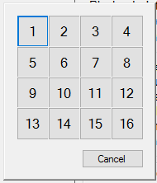

## 5.2 Management Class (Management.cs)

The Management class is comprised of two sections. The first section contains global variables to store information used by different methods inside the forms.

The second section contains a number of methods used to provide functionality to the Sleep Monitor main window. The main functionality provided is listed below:

* Calculate pixel values for an image
* Express a file size in human readable form
* Provide a folder dialogue to specify a folder
* Get the contents of a folder and filter according to the settings
* Translate an image counter number to a sleep segment number
* Calculate timestamps relating to a sleep segment number
* Export to CSV

## 5.3 Preferences (Form6.cs and Form2.cs)

When the user clicks the tool strip menu item Edit -> Preferences or the keyboard shortcut F8 is pressed Form6 is opened which shows basic preferences and is shown in the screenshot below:

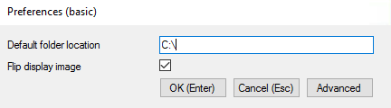

When the advanced button is clicked the advanced preferences window is opened which contains the two preferences shown in the basic window as well as others:

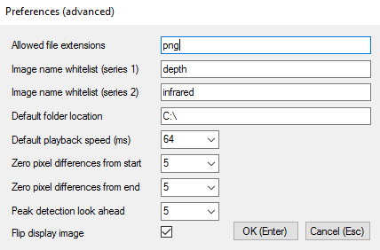

The functions of the different preference items are outlined in the table below:

|  |  |  |  |
| --- | --- | --- | --- |
| Preference | Basic | Type | Functionality |
| Allowed file extensions | No | Free text | List of file extensions allowed when new images are loaded into program. Must have at least one entry. Default is “png”. |
| Image name whitelist (series 1) | No | Free text | Whitelist term for images to be loaded into series 1 which is series used to calculate pixel differences displayed in chart. If field is blank then all images in input folder will be attempted to be loaded. Default is “depth”. |
| Image name whitelist (series 2) | No | Free text | Whitelist term for images to be loaded into series 2 which provides alternative display images. If field is blank then alternative display images will be unavailable. Default is “infrared”. |
| Default folder location | Yes | Free text | Default location opened when loading new images into program. Default is “C:\”. |
| Default playback speed (ms) | No | Combo box | Allows the user to set the default playback speed. Default is 64. Range is 2 – 1024. |
| Zero pixel differences from start | No | Combo box | Zeros out pixel differences by number of frames at start of series to avoid spikes relating to set up which affect scale on chart. Default is 5. Range is 0 – 9. |
| Zero pixel differences from end | No | Combo box | Zeros out pixel differences by number of frames at end of series to avoid spikes relating to shut down which affect scale on chart. Default is 5. Range is 0 – 9. |
| Peak detection look ahead | No | Combo box | Number of frames to look ahead when pixel difference exceeding threshold is detected. Avoids having multiple consecutive segment markers relating to a single movement. Maximum value in look ahead range is taken as segment point. Default is 5. Range is 0 – 9. |
| Flip display image | Yes | Check box | Flips image on x axis before displaying in image box. Default is checked. |

When either of the preference windows are opened, the preferences saved in App.config are loaded into the form.

When OK is clicked in either the basic or advanced preference windows, the fields that have free input, such as allowed file extensions, are parsed before saving. Parsing involves removing duplicates regardless of case, removing whitespace, and detecting invalid input. If invalid input is detected a warning window is displayed and the user is returned to the preferences window to make changes before trying to save again. Preferences are saved in App.config which allows them to persist between usage sessions. If cancel is selected none of the changes are saved.

## 5.4 About This Software (Form5.cs)

This a basic form that is triggered by clicking on the tool strip menu item Help -> About. The purpose of this form is to provide the user with basic information about the software and is shown in the screenshot below:

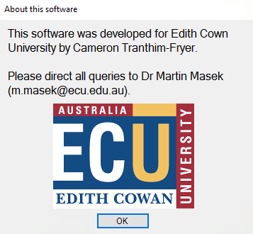

## 5.5 Help

When the user clicks the tool strip menu item Help -> View Help, or presses the keyboard shortcut F1, the file help.pdf located in the same folder as sleep.monitor.exe is opened using the default Windows application for opening PDF files. This allows the user to browse information about how to use the software.

# References

EmguCV Commercial Licence Purchase (2016). Retrieved from <http://www.emgu.com/wiki/index.php/Commercial_License_Purchase>

EmguCV Download and Installation (2016). Retrieved from <http://www.emgu.com/wiki/index.php/Download_And_Installation>

EmguCV Licence Version 3.0 (n.d.). Retrieved from <http://www.emgu.com/wiki/files/Emgu.CV.Commercial.License.3.0.pdf>

EmguCV Licencing (2016). Retrieved from <http://www.emgu.com/wiki/index.php/Licensing>:

EmguCV Wiki (2016). Retrieved from <http://www.emgu.com/wiki/index.php/Main_Page>

OpenCV About (2016). Retrieved from <http://opencv.org/about.html>

OpenCV Licence (2016). Retrieved from <http://opencv.org/license.html>

Sharp, J. (2015). Microsoft® Visual C#® Step by Step (8th ed.). Microsoft Press.

# Appendix 1 – OpenCV Licence

By downloading, copying, installing or using the software you agree to this license.

If you do not agree to this license, do not download, install, copy or use the software.

License Agreement

For Open Source Computer Vision Library

(3-clause BSD License)

Redistribution and use in source and binary forms, with or without modification, are permitted provided that the following conditions are met:

* Redistributions of source code must retain the above copyright notice, this list of conditions and the following disclaimer.
* Redistributions in binary form must reproduce the above copyright notice, this list of conditions and the following disclaimer in the documentation and/or other materials provided with the distribution.
* Neither the names of the copyright holders nor the names of the contributors may be used to endorse or promote products derived from this software without specific prior written permission.

This software is provided by the copyright holders and contributors “as is” and any express or implied warranties, including, but not limited to, the implied warranties of merchantability and fitness for a particular purpose are disclaimed. In no event shall copyright holders or contributors be liable for any direct, indirect, incidental, special, exemplary, or consequential damages (including, but not limited to, procurement of substitute goods or services; loss of use, data, or profits; or business interruption) however caused and on any theory of liability, whether in contract, strict liability, or tort (including negligence or otherwise) arising in any way out of

the use of this software, even if advised of the possibility of such damage.

(“OpenCV Licence,” 2016)

# Appendix 2 – EmguCV Licence

THIS DOCUMENT IS A LEGAL AGREEMENT (the "License Agreement") BETWEEN EMGU Corporation ("We," "Us") AND YOU OR THE ORGANIZATION ON WHOSE BEHALF YOU ARE UNDERTAKING THE LICENSE DESCRIBED BELOW ("You") IN RELATION TO THE EMGU CV SOFTWARE (THE "Software"), IN BOTH SOURCE AND OBJECT CODE FORM, AND/OR ALL RELATED MATERIALS. BY DOWNLOADING, INSTALLING, COPYING OR OTHERWISE USING THE SOFTWARE, YOU ACCEPT THE FOLLOWING TERMS AND CONDITIONS. IF YOU DO NOT AGREE WITH ANY OF THE TERMS OR CONDITIONS OF THIS LICENSE AGREEMENT, DO NOT PROCEED WITH THE DOWNLOADING, COPYING, INSTALLATION OR ANY OTHER USE OF THE SOFTWARE OR ANY PORTION THEREOF. THE SOFTWARE IS PROTECTED BY UNITED STATES COPYRIGHT LAWS AND INTERNATIONAL COPYRIGHT LAWS, AS WELL AS OTHER INTELLECTUAL PROPERTY LAWS AND TREATIES. THE SOFTWARE IS LICENSED, NOT SOLD.

THIS LICENSE AGREEMENT DESCRIBES YOUR RIGHTS WITH RESPECT TO THE SOFTWARE AND ITS COMPONENTS.

We, EMGU Corporation, grant You a non-exclusive, non-transferable license to the Software solely as set forth in sections 1(a), 1(b) or 1(c), as applicable, and subject to the terms and conditions of this License Agreement.

1. OWNERSHIP, LICENSE GRANT

This is a license agreement and not an agreement for sale. We reserve ownership of all intellectual property rights inherent in or relating to the Software, which include, but are not limited to, all copyright, patent rights, all rights in relation to registered and unregistered trademarks (including service marks), confidential information (including trade secrets and know-how) and all rights other than those expressly granted by this Agreement.

a. Developer License:

Subject to the payment of the fee required for a Commercial Developer License and subject to the terms and conditions of this License Agreement, We grant to You a revocable, non-transferable and non- exclusive license

1. for a single developer within Your organization to install and use the Software on any workstations used exclusively by such developer and
2. for You to install and use the Software in unlimited clients, solely in connection with distribution of the Software in accordance with sections 3 and 4 below. This license is not sub-licensable except as explicitly set forth herein.

b. Workgroup License:

Subject to the payment of the fee required for a Commercial Developer License and subject to the terms and conditions of this License Agreement, We grant to You a revocable, non-transferable and non- exclusive license

1. for up to twenty five (25) developers within Your organization to install and use the Software on any workstations used exclusively by such developers and
2. for You to install and use the Software in unlimited clients, solely in connection with distribution of the Software in accordance with sections 3 and 4 below. This license is not sub-licensable except as explicitly set forth herein.

c. Enterprise License:

Subject to the payment of the fee required for a Commercial Developer License and subject to the terms and conditions of this License Agreement, We grant to You a revocable, non-transferable and non- exclusive license

1. for up to one hundred (100) developers within Your organization to install and use the Software on any workstations used exclusively by such developers and
2. for You to install and use the Software in unlimited clients, solely in connection with distribution of the Software in accordance with sections 3 and 4 below. This license is not sub-licensable except as explicitly set forth herein.

License a), b) or c) only cover the usage on the source and binary part implemented by Emgu Corporation, and do not cover any non-Emgu implemented library. Usage of Open CV binary is govern by BSD license, usage of ZedGraph is covered by LGPL license, Tesseract OCR is covered by Apache 2.0 license. Some algorithms implemented by OpenCV, such as SIFT, SURF and haar-cascade are patented in the U.S. It is your responsibility to check whether the algorithms you used are patented in your country and contact the patent owner if you want to use them in your commercial software. Open CV also use FFmpeg, which is under its own license. If you use video encoder and decoder in Open CV, it is likely that you are using FFmpeg components. Legal information regarding FFmpeg can be found at http://www.ffmpeg.org/legal.html. It is your responsibility to obey the license terms of the above 3rd party libraries.

2. PERMITTED USES, SOURCE CODE, MODIFICATIONS

We provide You with source code so that You can create Modifications of the original Software, where Modification means: a) any addition to or deletion from the contents of a file included in the original Software or previous Modifications created by You, or b) any new file that contains any part of the original Software or previous Modifications. While You retain all rights to any original work authored by You as part of the Modifications, We continue to own all copyright and other intellectual property rights in the Software.

3. DISTRIBUTION

You may distribute the Software in any applications, frameworks, or elements that you develop using the Software in accordance with this License Agreement, provided that such distribution does not violate the restrictions set forth in section 4 of this agreement. You must not remove, obscure or interfere with any copyright, acknowledgment, attribution, trademark, warning or disclaimer statement affixed to, incorporated in or otherwise applied in connection with the Software.

You are required to ensure that the Software is not reused by or with any applications other than those with which You distribute it as permitted herein. For example, if You install the Software on a customer's server, that customer is not permitted to use the Software independently of Your application, and must be informed as such.

You will not owe EMGU Corporation any royalties for Your distribution of the Software in accordance with this License Agreement.

4. PROHIBITED USES

You may not, without prior written consent of EMGU Corporation, redistribute the Software or Modifications other than by including the Software or a portion thereof within Your own product, which must have substantially different functionality than the Software or Modifications and must not allow any third party to use the Software or Modifications, or any portions thereof, for software development purposes. You are explicitly not allowed to redistribute the Software or Modifications as part of any product that can be described as a development toolkit or library or is intended for use by software developers and not end-users. You are not allowed to redistribute any part of the Software documentation.

You may not: a) use any part of the Software or Modifications or Your knowledge of the Software (or any information that You learn as a result of Your use of the Software) to create a product with the same or substantially the same functionality as the Software; b) transfer, rent, lease, or sublicense the Software or Modifications, or any portions thereof; c) change or remove the copyright notice from any of the files included in the Software or Modifications.

UNDER NO CIRCUMSTANCES MAY YOU USE THE SOFTWARE (INCLUDING WITHOUT LIMITATION THE SOURCE CODE THEREOF) AS THE BASIS FOR OR IN CONNECTION WITH A PRODUCT THAT CONTAINS THE SAME, OR SUBSTANTIALLY THE SAME, FUNCTIONALITY AS THE SOFTWARE.

5. TERMINATION

This License Agreement and Your right to use the Software and Modifications will terminate immediately without notice if You fail to comply with the terms and conditions of this License Agreement. Upon termination, You agree to immediately cease using and destroy the Software or Modifications, including all accompanying documents. The provisions of sections 4, 5, 6, 7, and 8 will survive any termination of this License Agreement.

6. DISCLAIMER OF WARRANTIES

TO THE MAXIMUM EXTENT PERMITTED BY APPLICABLE LAW, EMGU CORPORATION AND ITS SUPPLIERS DISCLAIM ALL WARRANTIES AND CONDITIONS, EITHER EXPRESS OR IMPLIED, INCLUDING, BUT NOT LIMITED TO, IMPLIED WARRANTIES OF MERCHANTABILITY, FITNESS FOR A PARTICULAR PURPOSE, TITLE AND NON-INFRINGEMENT, WITH REGARD TO THE SOFTWARE. EMGU CORPORATION DOES NOT GUARANTEE THAT THE OPERATION OF THE SOFTWARE WILL BE UNINTERRUPTED OR ERROR-FREE, AND YOU ACKNOWLEDGE THAT IT IS NOT TECHNICALLY PRACTICABLE FOR EMGU CORPORATION TO DO SO.

7. LIMITATION OF LIABILITIES

TO THE MAXIMUM EXTENT PERMITTED BY APPLICABLE LAW, IN NO EVENT SHALL EMGU CORPORATION OR ITS SUPPLIERS BE LIABLE FOR ANY SPECIAL, INCIDENTAL, INDIRECT OR CONSEQUENTIAL DAMAGES WHATSOEVER (INCLUDING, WITHOUT LIMITATION, DAMAGES FOR LOSS OF BUSINESS PROFITS, BUSINESS INTERRUPTION, LOSS OF BUSINESS INFORMATION OR ANY OTHER PECUNIARY LAW) ARISING OUT OF THE USE OF OR INABILITY TO USE THE SOFTWARE, EVEN IF EMGU CORPORATION HAS BEEN ADVISED OF THE POSSIBILITY OF SUCH DAMAGES. IN ANY CASE, EMGU CORPORATION'S ENTIRE

LIABILITY UNDER ANY PROVISION OF THIS LICENSE AGREEMENT SHALL BE LIMITED TO THE GREATER OF THE AMOUNT ACTUALLY PAID BY YOU FOR THE SOFTWARE OR FIVE ($5.00) DOLLARS (USD).

8. MISCELLANEOUS

The license granted herein applies only to the version of the Software downloaded or installed in connection with the terms of this Agreement. Any previous or subsequent license granted to You for use of the Software shall be governed by the terms and conditions of the agreement entered in connection with downloading or installation of that version of the Software.

You agree that you will comply with all applicable laws and regulations with respect to the Software, including without limitation all export and re-export control laws and regulations.

While redistributing the Software or Modifications thereof, You may choose to offer acceptance of support, warranty, indemnity, or other liability obligations and/or rights consistent with this Agreement. However, in accepting such obligations, You may act only on Your own behalf and on Your sole responsibility, not on our behalf. You agree to indemnify, defend, and hold Us harmless from and against any liability incurred by, or claims asserted against, Us by reason of Your accepting any such support, warranty, indemnity or additional liability.

You agree to be identified as a customer of ours and You agree that We may refer to You by name, trade name and trademark, if applicable, and may briefly describe Your business in our marketing materials and web site.

You may not assign this License Agreement without the prior written consent of EMGU CORPORATION. This License Agreement will inure to the benefit of the successors and assigns of EMGU CORPORATION.

You acknowledge that this License Agreement is complete and is the exclusive representation of our agreement. No oral or written information given by Us or on our behalf shall create a warranty or collateral contract, or in any way increase the scope of this License Agreement in any way, and You may not rely on any such oral or written information.

If any provision in this License Agreement shall be determined to be invalid, such provision shall be deemed omitted; the remainder of this License Agreement shall continue in full force and effect.

This License Agreement may be modified only by a written instrument signed by an authorized representative of each party.

If the Software or any related documentation is licensed to the U.S. government or any agency thereof, it will be deemed to be "commercial computer software" or "commercial computer software documentation," pursuant to SFAR Section 227.7202 and FAR Section 12.212. Any use of the Software or related documentation by the U.S. government will be governed solely by the terms of this License Agreement.

(“EmguCV Licence Version 3.0,” n.d.)

# Appendix 3 – Sleep Monitor Main Window

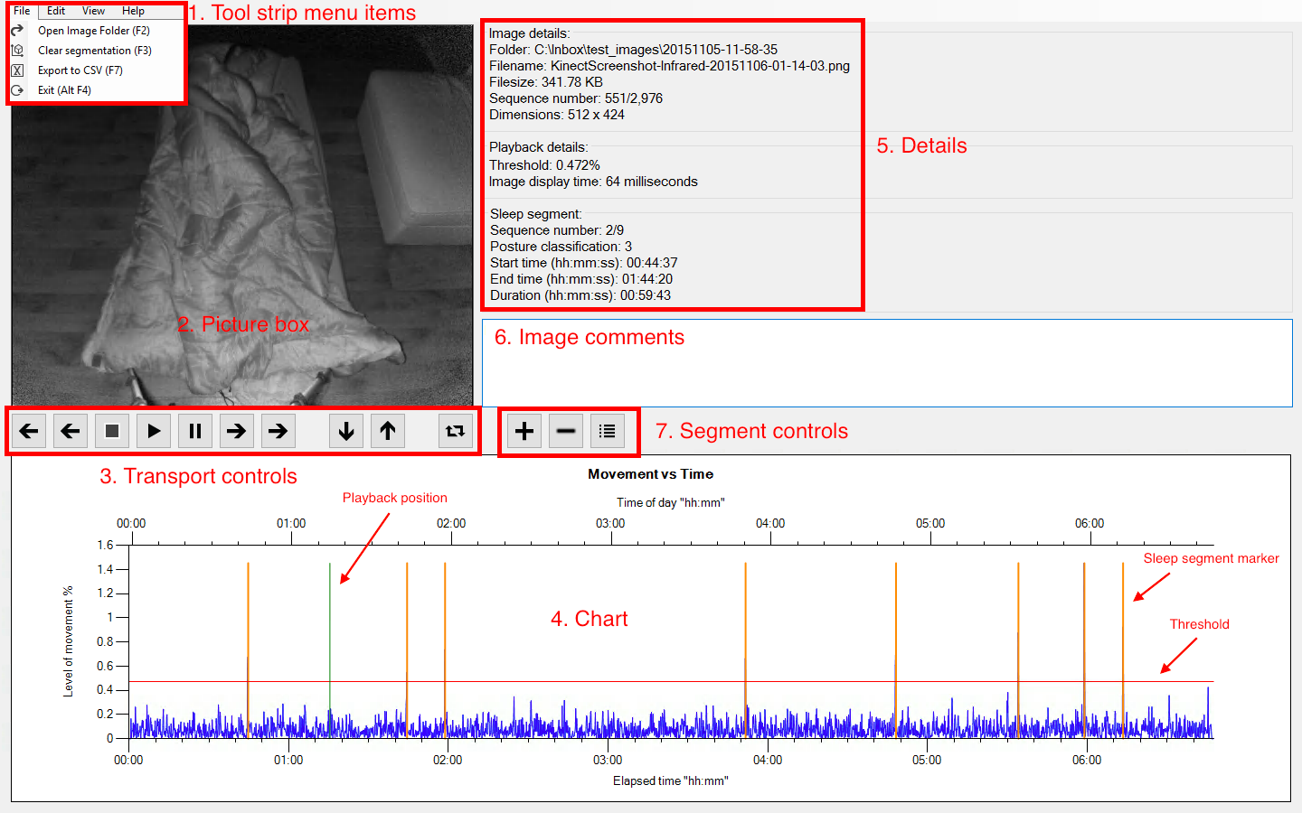

# Appendix 4 – Output.csv

|  |  |  |  |  |  |  |  |  |  |  |  |  |  |  |  |  |  |  |  |  |
| --- | --- | --- | --- | --- | --- | --- | --- | --- | --- | --- | --- | --- | --- | --- | --- | --- | --- | --- | --- | --- |
| Client: |  |  |  | |  | | |  | | | | |  | |  | |  | |  | |
| Generated: 16-05-2016 04:45:04 | | | |  | |  | | | |  | |  | |  | |  | |  | | | |
| Folder: C:\Inbox\test_images\20151105-11-58-35 | | | |  | |  | | | |  | |  | |  | |  | |  | | | |
| Threshold value: 0.5218% | | | |  | |  | | | |  | |  | |  | |  | |  | | | |
| Total sleep time: 06:47:28 | | | |  | |  | | | |  | |  | |  | |  | |  | | | |
| Images in series: 2976 | | | |  | |  | | | |  | |  | |  | |  | |  | | | |
| ***************************************************************************************** | | | | | | | | |  | | |  | |  | |  | |  | | | |
| Image # | Segment # | Image Name | Comment | | Side | | | SSL | | | | | Position | | Segment Duration | | Time (relative) | | Time (absolute) | |
| 1 | 1 | KinectScreenshot-Depth-20151105-23-58-45.png | | | | |  |  | | | 1 | | | 44.6 minutes | | 0:00:00 | | 5/11/2015 23:58 | | | |
| 327 | 2 | KinectScreenshot-Depth-20151106-00-43-22.png | | | | |  |  | | | 2 | | | 59.7 minutes | | 0:44:37 | | 6/11/2015 0:43 | | | |
| 763 | 3 | KinectScreenshot-Depth-20151106-01-43-05.png | | | | |  |  | | | 3 | | | 14.2 minutes | | 1:44:20 | | 6/11/2015 1:43 | | | |
| 867 | 4 | KinectScreenshot-Depth-20151106-01-57-19.png | | | | |  |  | | | 4 | | | 112.9 minutes | | 1:58:34 | | 6/11/2015 1:57 | | | |
| 1097 | 4 | KinectScreenshot-Depth-20151106-02-28-51.png | Random comment | | | | |  | | | | |  | |  | | 2:30:06 | | 6/11/2015 2:28 | |
| 1691 | 5 | KinectScreenshot-Depth-20151106-03-50-13.png | | | | |  |  | | | 0 | | | 56.5 minutes | | 3:51:28 | | 6/11/2015 3:50 | |
| 2104 | 6 | KinectScreenshot-Depth-20151106-04-46-44.png | | | | |  |  | | | 0 | | | 46 minutes | | 4:47:59 | | 6/11/2015 4:46 | |
| 2440 | 7 | KinectScreenshot-Depth-20151106-05-32-45.png | | | | |  |  | | | 0 | | | 24.8 minutes | | 5:34:00 | | 6/11/2015 5:32 | |
| 2621 | 8 | KinectScreenshot-Depth-20151106-05-57-32.png | | | | |  |  | | | 0 | | | 14.5 minutes | | 5:58:47 | | 6/11/2015 5:57 | |
| 2727 | 9 | KinectScreenshot-Depth-20151106-06-12-03.png | | | | |  |  | | | 0 | | | 34.2 minutes | | 6:13:18 | | 6/11/2015 6:12 | |
| ***************************************************************************************** | | | | | | | | |  | | |  | |  | |  | |  | |

|  |  |  |  |  |  |
| --- | --- | --- | --- | --- | --- |
| Sleep Position | Total Duration | % of Total | # Occurrences | Average Duration | |
| 0 | 176 minutes | 43.2 | 5 | 35.2 minutes | |
| 1 | 44.6 minutes | 10.9 | 1 | 44.6 minutes | |
| 2 | 59.7 minutes | 14.7 | 1 | 59.7 minutes | |
| 3 | 14.2 minutes | 3.5 | 1 | 14.2 minutes | |
| 4 | 112.9 minutes | 27.7 | 1 | 112.9 minutes | |
| 5 | 0 minutes | 0 | 0 | 0 minutes |  |
| 6 | 0 minutes | 0 | 0 | 0 minutes |  |
| 7 | 0 minutes | 0 | 0 | 0 minutes |  |
| 8 | 0 minutes | 0 | 0 | 0 minutes |  |
| 9 | 0 minutes | 0 | 0 | 0 minutes |  |
| 10 | 0 minutes | 0 | 0 | 0 minutes |  |
| 11 | 0 minutes | 0 | 0 | 0 minutes |  |
| 12 | 0 minutes | 0 | 0 | 0 minutes |  |
| 13 | 0 minutes | 0 | 0 | 0 minutes |  |
| 14 | 0 minutes | 0 | 0 | 0 minutes |  |
| 15 | 0 minutes | 0 | 0 | 0 minutes |  |
| 16 | 0 minutes | 0 | 0 | 0 minutes |  |